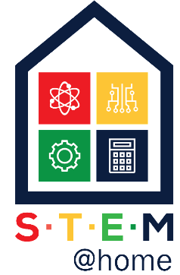 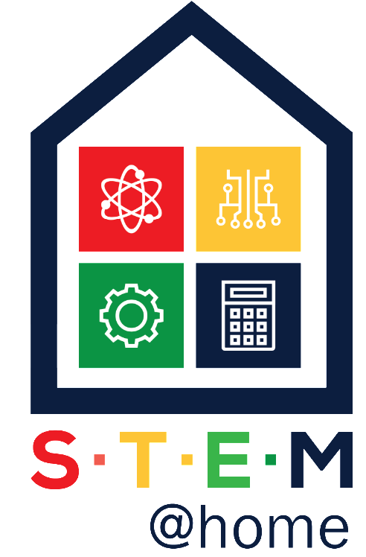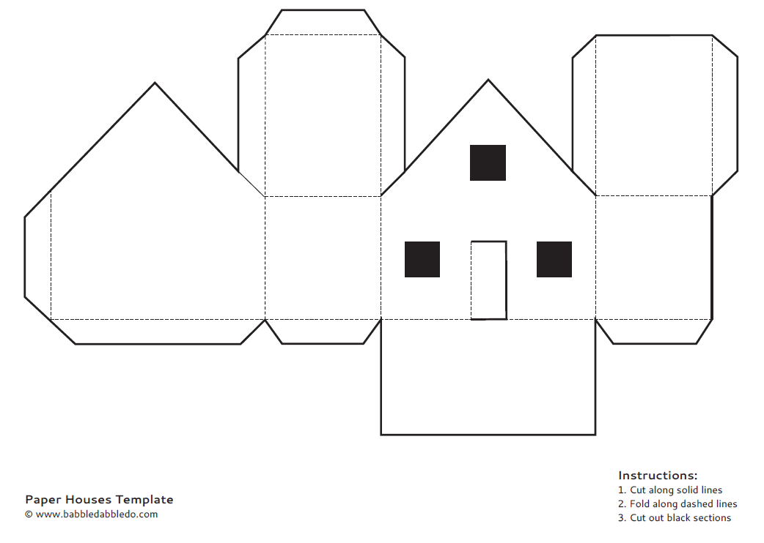

More ideas on….**TinkeringChild.com**

Design and make a paper plane. How far will it fly? Make a second plane. Is it faster/ slower than the first? Which one travels further?



Design and make a catapult. Use elastic bands, sticks and a spoon. How far can it catapult an object? 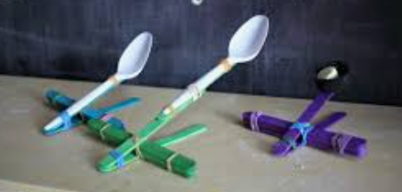

Make a Cipher Wheel to write secret messages. Cut two circle, one larger than the other. Write the alphabet on each. Use a paper fastener to hold together. Shift to code.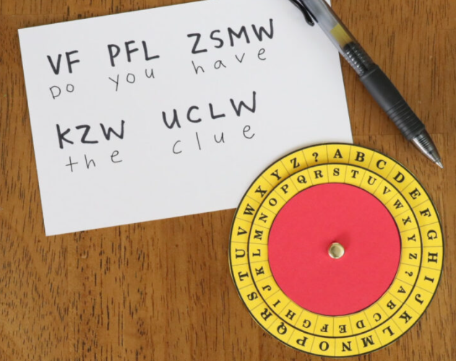

Algorithms are step by step instructions to solve problems or tasks. Write an algorithm to make a jam sandwich. Give your algorithm to someone to see if your algorithm is successful.

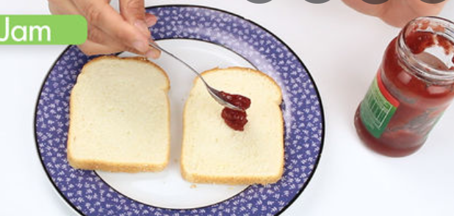 Did you have to change anything?

Building Bridges from materials around your home. Who can build the strongest and/or longest bridge? 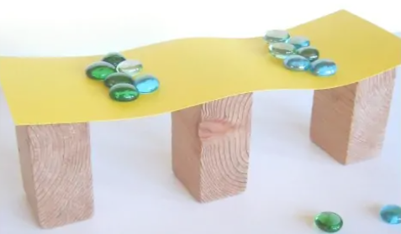

Make a xylophone using glasses filled with different amounts of water. Tap them with a spoon. Try creating your own song and lyrics!



**Learn while having fun with these STEM activities. Colour each part of the house as you complete the activity. Finish by constructing the house! Bring it into school to show your friends 😊**

Rube Goldberg machines are so much fun to create using materials from all around the house to create a chain reaction to complete a simple task in a fun and crazy way! Example [Feeding the dog!](https://www.youtube.com/watch?v=OHwDf8njVfo)

[Caine’s Arcade](https://www.youtube.com/watch?v=faIFNkdq96U) inspires you to create cardboard arcade games. Watch how Caine created his cardboard arcade, the story itself is beautiful, and then make arcade games to entertain the family!