How to make a Hologram Video
- Video yourself reciting your poem.
- Export video from camera roll into video editor.
- Trim video
- Save
How to make Hologram on Power Point
- Open Power Point
- Click on shapes and draw rectangle over whole slide.
- Fill with black.
- Insert video from computer onto Power Point slide, click media, video, from computer.
- Crop to just the head.
- Now blend black by clicking on video, go to format then corrections.
- Select the best correction (more in options)
- Duplicate video 4 times and rotate each one to make hologram set up
- 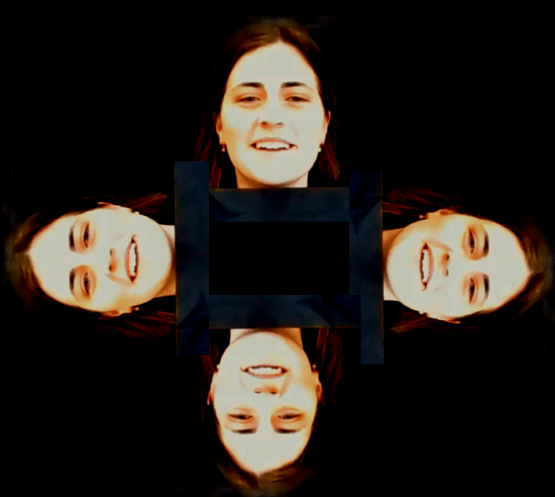
- Now to align. Go to Animation. Click Animation Pane.
- Click on each video and drag in animation pane to get rid of trigger.
- Highlight each video and click start. Click start with previous.
- Can add animation to zoom in etc

