Year 5 Robotics Competition

Everyone to have FUN!
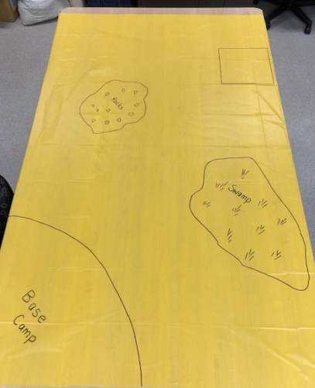
- Each team will have a mat in the colour of their house.
- In the allocated time the teams need to see how many times they can bring the LEGO crate to base. Each attempt must start in base. (Team members will need to hold the mat firmly at the corners)
- The EV3 needs to be programmed to leave base, collect the LEGO crate and return it to base.
- 20 points each time the task is completed
- 5 points deducted for rocks or swamp
- 5 points deducted for losing LEGO crate
- There will be a large timer on the CHC screen, so girls can enjoy a count-down to finish!
https://www.online-stopwatch.com/robot-race/full-screen/ (Might like to familiarise the girls with this so they are not too distracted on the day)
- Teams will have 2 turns at the competition (girls maybe changed into teams)
- The idea is to let all girls have a turn :) if they would like to!
- After both games, add up points and give to scorers.

