Year 4 Robotics Competition

The purpose of the competition is for everyone to have FUN!
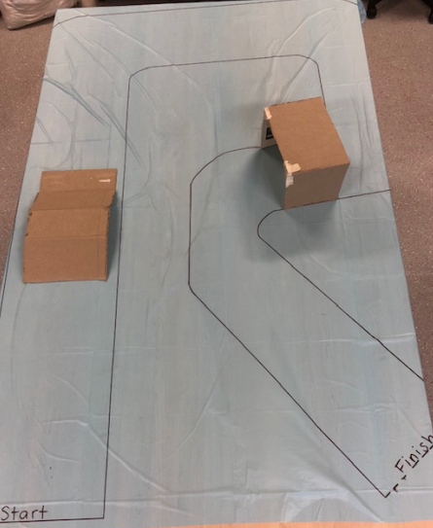

- Each team will a maze in the colour of their house.
- In the allocated time the teams need to see how many times they can complete the maze.
- The Sphero needs to be in drive mode to follow the maze (staying within the lines)
- 10 points for following the maze (staying within the lines)
- 5 points awarded for going over the ramp
- 5 points awarded for going through the tunnel
- There will be a large timer on the CHC screen, so girls can enjoy a count-down to finish!
https://www.online-stopwatch.com/robot-race/full-screen/ (Might like to familiarise the girls with this so they are not too distracted on the day)
- Teams will have 2 turns at the competition (girls maybe changed into teams)
- The idea is to let all girls have a turn :) if they would like to!
- After both games, add up points and give to scorers.

