Year 2 Robotics Competition….

…..is to have FUN!
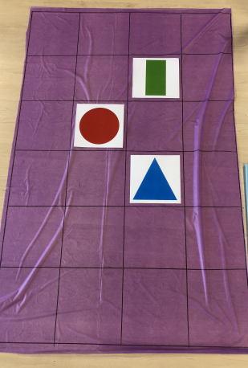

- Each team will have a mat in their house colour.
- The start and finish labels and balloon will be placed by the teacher (each house must start and finish in same square)
- The girls will be programming the Blue Bot to travel over each shape to get to the balloon and burst it!
- The team will get 20 points every time the course is completed, and balloon is burst, in the time allocated.
- 5 points can be awarded for every shape that is covered but balloon is not burst.
- There will be a large timer on the CHC screen so girls can enjoy a count-down to finish!
https://www.online-stopwatch.com/robot-race/full-screen/ (Might like to familiarise the girls with this so they are not too distracted on the day)
- Teams will have 2 turns at the competition (girls maybe changed into teams)
- The idea is to let all girls have a turn :) if they would like to!
- After both games, add up points and give to scorers.
