Sphero Edu Activity
In this game, toss Sphero between friends and guess the random animal sound that plays. Guess wrong and you're OUT, and you'll need to act out the correct animal in front of everyone for good measure. This program shows how the accelerometer sensor can trigger an "if then" statement, which is a very common concept in programming. Animal Toss uses the accelerometer to detect readings over 3G's, and the "if then" statement plays a random animal sound at that sensor threshold. That's an "if then" statement... if this happens, then something else happens.
The animals you will hear are: Alligator, Bear, Bird, Cat, Chicken, Cow, Dog, Dolphin, Donkey, Duck, Elephant, Frog, Horse, Horse Gallop, Lion, Monkey, Pig, Rooster, Sea Lion, Sheep, Tiger, Whale
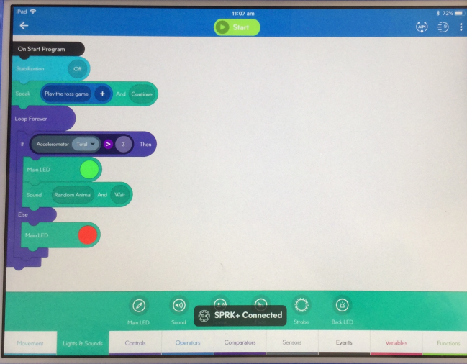
This is from ‘Thursday Learn Day’, they have some fun activities for all ages. The programs can be copied, and the children learn new functions!
https://www.youtube.com/watch?v=EvYB-gwxRwI
https://edu.sphero.com/cwists/preview/2143x
