Making a Hologram Image on Power Point
- Using laminating sheets sealed cut out 4 quadrilaterals
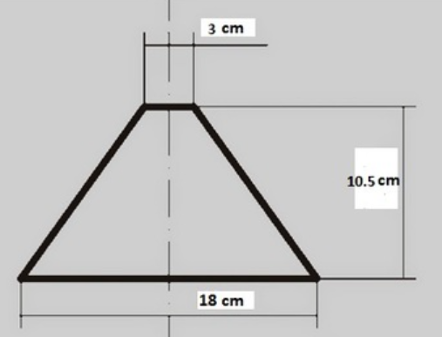
Use clear tape to connect all 4 to make a pyramid
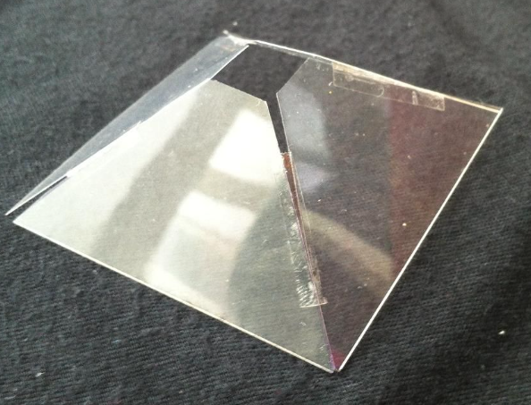

- Make Video of child reciting verse they created responding to message from book ie ways children settled into their new life in Australia. Use black back ground for effect (can dress in black to make more interesting with only head and hands showing!)

- Making a Power Point for Hologram
Open new slide on power point and go to design tab and select format background and fill with black.
Now insert video onto slide, select cropping tool from format and crop to a smaller size (remember there will be 4 videos on the slide)
Once the video is inserted, the black surrounding the image needs to match the black slide so click on video, go to format and corrections. Play around with the brightness and contrast till it matches.
Now the video needs to be placed 4 times on the slide. So, go to insert and click shapes. Select the ‘x’ in equation shapes and on the yellow dot decrease the thickness. Place the cross in the centre of the slide, go to format and align to centre.
Now move video into top area of cross. With video selected press control D to duplicate 3 times. Place each video into an area of cross. Make sure orientation is correct ie if feet are at bottom near centre of cross then make sure video is the same in each area.
Now highlight the cross and delete.
The videos have to be synchronised to start together. Open animation tab and select all videos and select start with previous. This should sync them to start at the same time.

- Place screen flat and place prism on top. Now play and get at eye level to watch your hologram.

shttps://powerpointspice.wordpress.com/2016/06/24/how-to-make-a-hologram-of-yourself-in-powerpoint/

