

**NAME: FORM:**

**Subject : Year 6 History: Living Under The Act**

**Assessment Task : Short Film Documentary**

**Due Date : Thurs 25 May, Week 6, Term 2, 2017**

**Inquiry Focus**

What was life like ‘Living Under the Act’ and are there still issues today?

1. With your partner, select a time from Federation till present day to investigate the lives of Aboriginal people.
2. Using the focus questions provided, research either an individual or period of time, and record your findings in a your note book.
3. Locate both primary and secondary sources as part of your research to support your findings (images, photographs, documents, cartoons). Your partnership must refer to, at a minimum, one primary and two secondary sources and be accompanied by a Reference List.
4. Your documentary will be part of Year 6 ‘Living Under The Act Documentary’, red carpet premiere will be Thursday 15 June.

**Conditions :**

* Students will work in pairs to research and film a documentary.
* Students must submit their individual notebooks with research notes.
* Students should submit their inquiry questions to be signed and approved by the teacher.
* Students will hand in note book and documentary in Week 6.
* Students will share their documentary with invited audience on Thursday 15 June……with ‘red carpet’!



#### Year 6 Achievement Standard

By the end of Year 6, students [identify](http://v7-5.australiancurriculum.edu.au/glossary/popup?a=F10AS&t=Identify) change and continuity and [describe](http://v7-5.australiancurriculum.edu.au/glossary/popup?a=F10AS&t=Describe) the causes and effects of change on society. They [compare](http://v7-5.australiancurriculum.edu.au/glossary/popup?a=F10AS&t=Compare) the different experiences of people in the past. They [explain](http://v7-5.australiancurriculum.edu.au/glossary/popup?a=F10AS&t=Explain) the significance of an individual and group.

Students [sequence](http://v7-5.australiancurriculum.edu.au/glossary/popup?a=F10AS&t=Sequence) events and people (their lifetime) in chronological order, and [represent](http://v7-5.australiancurriculum.edu.au/glossary/popup?a=F10AS&t=Represent) time by creating timelines. When researching, students [develop](http://v7-5.australiancurriculum.edu.au/glossary/popup?a=F10AS&t=Develop) questions to frame an historical inquiry. They [identify](http://v7-5.australiancurriculum.edu.au/glossary/popup?a=F10AS&t=Identify) a range of sources and [locate](http://v7-5.australiancurriculum.edu.au/glossary/popup?a=F10AS&t=Locate) and [compare](http://v7-5.australiancurriculum.edu.au/glossary/popup?a=F10AS&t=Compare) information to answer inquiry questions. They [examine](http://v7-5.australiancurriculum.edu.au/glossary/popup?a=F10AS&t=Examine) sources to [identify](http://v7-5.australiancurriculum.edu.au/glossary/popup?a=F10AS&t=Identify) and [describe](http://v7-5.australiancurriculum.edu.au/glossary/popup?a=F10AS&t=Describe) points of view. Students [develop](http://v7-5.australiancurriculum.edu.au/glossary/popup?a=F10AS&t=Develop) texts, particularly narratives and descriptions. In developing these texts and organising and presenting their information, they use historical terms and concepts and incorporate relevant sources.

ACARA Australian Curriculum HAS

**Decide either an Aboriginal person’s story, event or experiences of Aboriginal people today. Use:**

1. Pictures……drawn, painted, background
2. Photos……family, environment
3. Maps…..journey, route
4. Dates……headings, time lapse
5. Quotes…..written, spoken
6. Interviews…..scripts

**Using Do Ink App and iMovie to record and present your information as a documentary.**



**Use Historical Language**

When writing responses to your questions, you must include historical language. Historical language refers to terms that relate to the topic you are investigating.

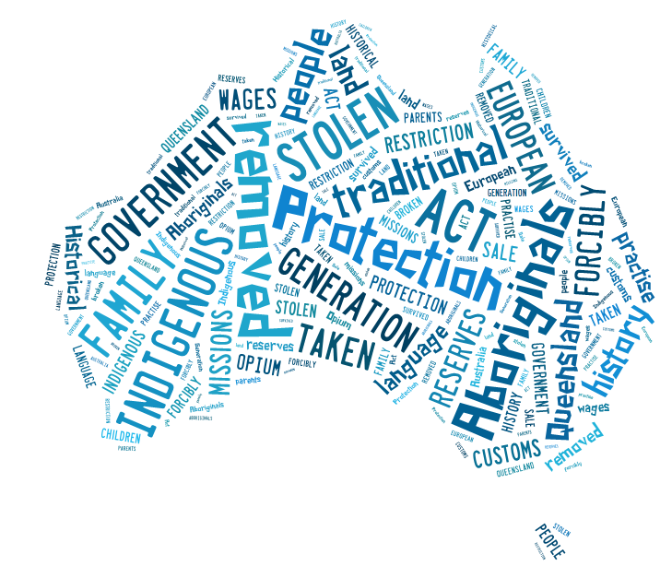

**Background Research:**

**Develop Inquiry Questions**

Write inquiry questions to guide your research on what life was like for Aboriginal people living under The Act. Aboriginal people survived, but the effects of these restrictions continue to be felt by succeeding generations as they rebuild family networks and cultural links. You may like to build on the following questions to begin your inquiry process:

**Who?** Who or what period in Aboriginal history are you studying?

Who lived under The Act? Who wrote the Act? Who made changes? Who did it affect?

**What?** What is ‘The Act’? What does it mean ‘living under’ the Act?

What happened when the Act was passed?

**When?** When did the Act become law? When did things change?

**Where?** Where did the children go? Where did families go?

**Why?** Why was the Act introduced? Why did officials remove children from their families?

**How?** How did this Act affect Australian society? How have Aboriginal cultures and families survived?

**Main Inquiry Question:**

What was life like for…………………….. living under the Act ?

Or your own….

___________________________________________

Teacher’s Signature ________________________________________________ Date: ________________________

Main Research Areas:

Select significant events from the life or event you have researched and sequence them on this **timeline**. You can include events that are personally significant to the person and events that were significant to the wider world.

Script for Documentary

Ideas for documentary….images, script

|  |  |
| --- | --- |
|  |  |
|  |  |
|  |  |

|  |  |
| --- | --- |
| Year 6 History: Unit 2: Research — Aboriginal experiences | Name: Partner: |

**Purpose:** To conduct an historical inquiry to investigate the experiences of Aboriginal people ‘Living Under The Act’.

|  |  |  |  |  |
| --- | --- | --- | --- | --- |
| UNDERSTANDING | SKILLS | | | |
| Historical Knowledge and Understanding | Questioning and researching | Analysing and interpreting | | Communicating |
| Explain the significance of an individual and group | Develops questions to frame an historical inquiry | Identifies a range of sources Locates and compares information to answer inquiry questions | | Sequences events in chronological order Develops a documentary using historical terms and concepts and incorporating relevant sources |  |
| Integrates information from a range of sources to develop texts  Briefly describes the experiences  Lists questions about the topic  Describes the experiences of lives of Aboriginal people  Asks some questions about Aboriginal experiences  Explains the significance of an individual or event  Develops questions to inform an historical inquiry  Explains the different experiences of Aboriginal people  Composes questions to locate information in sources  Develops a sequence of connected questions  Analyses the significance of Aboriginal people living under the Act. | | | Makes cohesive links in script and images | | A |
|  | | |  | |
| Interprets information located in sources | | | Integrates sources to enhance meaning  Relates personal events to historical events | | B |
|  | | |  | |
| Records information from sources  Selects information from sources to answer questions  Identifies a range of sources  Locates and compares information to answer inquiry questions | | | Lists facts and events about Aboriginal people  States history, experiences and experiences of Aboriginal people  Sequences events in chronological order  Develops a script using historical terms and concepts and incorporating relevant sources | | C |
|  | | |  | |
|  | | |  | | D |
|  | | |  | |
|  | | |  | | E |
|  | | |  | |

**Feedback: Teacher Signature:** ______________________________________