

**NAME: FORM:**

**Subject : Year 6 History: Making Australia Home**

**Assessment Task : Migrant Story**

**Due Date : Thurs 10 November , Week 6, Term 2, 2016**

**Inquiry Focus**

Who has migrated to Australia over time and what impact have migrants had on Australian identity and society?

1. With your partner, select either a known migrant or refugee or unknown migrant or refugee to investigate.
2. Using the focus questions provided, research the migrant or refugee, and record your findings in a your note book.
3. Locate both primary and secondary sources as part of your research to support your findings (images, photographs, documents, cartoons). Your partnership must refer to, at a minimum, one primary and two secondary sources and be accompanied by a Reference List.
4. Select a method of your choice to present your migrant’s story for example animation, movie, eBook, song, collage, interactive.

**Conditions :**

* Students will work in pairs to research and choose the method of how to present their migrant story.
* Students must submit their individual notebooks with research notes.
* Students should submit their inquiry questions to be signed and approved by the teacher.
* Students will present their story to the class in Week 6.



#### Year 6 Achievement Standard

By the end of Year 6, students [identify](http://v7-5.australiancurriculum.edu.au/glossary/popup?a=F10AS&t=Identify) change and continuity and [describe](http://v7-5.australiancurriculum.edu.au/glossary/popup?a=F10AS&t=Describe) the causes and effects of change on society. They [compare](http://v7-5.australiancurriculum.edu.au/glossary/popup?a=F10AS&t=Compare) the different experiences of people in the past. They [explain](http://v7-5.australiancurriculum.edu.au/glossary/popup?a=F10AS&t=Explain) the significance of an individual and group.

Students [sequence](http://v7-5.australiancurriculum.edu.au/glossary/popup?a=F10AS&t=Sequence) events and people (their lifetime) in chronological order, and [represent](http://v7-5.australiancurriculum.edu.au/glossary/popup?a=F10AS&t=Represent) time by creating timelines. When researching, students [develop](http://v7-5.australiancurriculum.edu.au/glossary/popup?a=F10AS&t=Develop) questions to frame an historical inquiry. They [identify](http://v7-5.australiancurriculum.edu.au/glossary/popup?a=F10AS&t=Identify) a range of sources and [locate](http://v7-5.australiancurriculum.edu.au/glossary/popup?a=F10AS&t=Locate) and [compare](http://v7-5.australiancurriculum.edu.au/glossary/popup?a=F10AS&t=Compare) information to answer inquiry questions. They [examine](http://v7-5.australiancurriculum.edu.au/glossary/popup?a=F10AS&t=Examine) sources to [identify](http://v7-5.australiancurriculum.edu.au/glossary/popup?a=F10AS&t=Identify) and [describe](http://v7-5.australiancurriculum.edu.au/glossary/popup?a=F10AS&t=Describe) points of view. Students [develop](http://v7-5.australiancurriculum.edu.au/glossary/popup?a=F10AS&t=Develop) texts, particularly narratives and descriptions. In developing these texts and organising and presenting their information, they use historical terms and concepts and incorporate relevant sources.

ACARA Australian Curriculum HAS

**Choose how to present your migrant’s story, include where possible**

1. Pictures……drawn, painted, background
2. Photos……family, environment
3. Maps…..journey, route
4. Dates……headings, time lapse
5. Quotes…..written, spoken
6. Interviews…..scripts

**Choose a mode, medium or software to tell their story**









**Use Historical Language**

When writing responses to your questions, you must include historical language. Historical language refers to terms that relate to the topic you are investigating. For example, terms related to migrants include identity, society, contribution, refugee, asylum seekers, suppressed and multiculturalism.

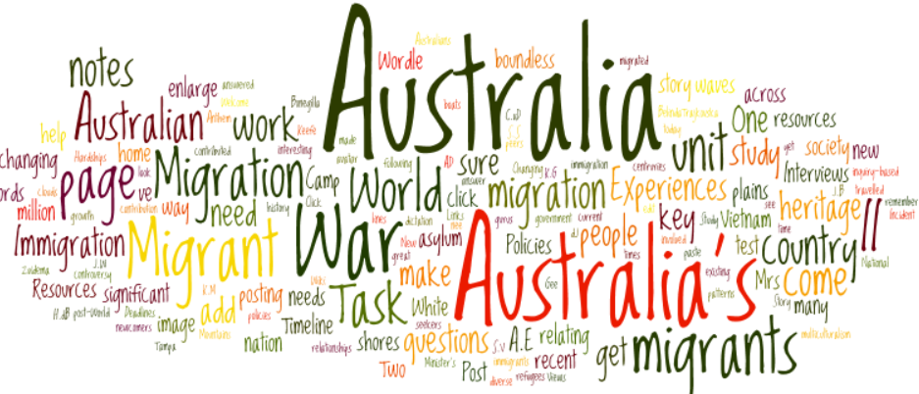

**Background Research:**

**Develop Inquiry Questions**

Write inquiry questions to guide your research into reasons for the migration to Australia of the person you have chosen. You may like to build on the following questions to begin your inquiry process:

**Who?** What is your migrant’s full name?

**What?** What nationality? What home country? What language?

**When?** What time in history was your migrant born? What events were occurring in their home country?

**Where?** Where exactly did your migrant come from?

**Why?** Why did your person migrate?

**How?** What circumstances led your person to move from their home country? Did they choose to migrate or were they forced?

**Main Inquiry Question:**

How did______________________________________________ ‘s life influence Australian society and identity?

Teacher’s Signature ________________________________________________ Date: ________________________

Main Research Areas:

Select significant events from the life of the migrant you have researched and sequence them on this **timeline**. You can include events that are personally significant to the migrant and events that were significant to the wider world

EARLY LIFE

REASONS TO MIGRATE

THE JOURNEY

SETTLING IN A NEW COUNTRY

CONTRIBUTIONS to AUSTRALIAN SOCIETY

Storyboard Presentation

|  |  |
| --- | --- |
|  |  |
|  |  |
|  |  |

|  |  |
| --- | --- |
| Year 6 History: Unit 2: Research — Migrant experiences | Name: Partner: |

**Purpose:** To conduct an historical inquiry to investigate the experiences of a migrant and their contributions to the development of Australian society and identity.

|  |  |  |  |  |
| --- | --- | --- | --- | --- |
| UNDERSTANDING | SKILLS | | | |
| Historical Knowledge and Understanding | Questioning and researching | Analysing and interpreting | | Communicating |
| Explain the significance of an individual and group | Develops questions to frame an historical inquiry | Identifies a range of sources Locates and compares information to answer inquiry questions | | Sequences events in chronological order Develops a digital story using historical terms and concepts and incorporating relevant sources |  |
| Integrates information from a range of sources to develop texts  Lists examples of contributions made by a migrant  Lists questions about a migrant  Describes the experiences and contribution of a migrant  Asks questions about the history, experiences and contribution of a migrant  Explains the significance of an individual  Develops questions to inform an historical inquiry  Explains the different experiences of migrants  Composes questions to locate information in sources  Develops a sequence of connected questions  Analyses the significance of migration to the development of diversity in Australia | | | Makes cohesive links in texts | | A |
|  | | |  | |
| Interprets information located in sources | | | Integrates sources to enhance meaning  Relates personal events to historical events | | B |
|  | | |  | |
| Records information from sources  Selects information from sources to answer questions  Identifies a range of sources  Locates and compares information to answer inquiry questions | | | Lists facts about a migrant or migrant group  Lists events  States history, experiences and contributions of a migrant or migrant group  Sequences events in chronological order  Develops a narrative using historical terms and concepts and incorporating relevant sources | | C |
|  | | |  | |
|  | | |  | | D |
|  | | |  | |
|  | | |  | | E |
|  | | |  | |

**Feedback: Teacher Signature:** ______________________________________