Programming the Parrot Rolling Spider

- Open ‘Tickle’ app on the iPads.

- Write a program to get the drone to these places in the library.

- Start at the door (set maximum height to 2m)
- Travel to the Think Tank table, doing 2 flips on the way.
- Land on the table and then take off to get to the taped cross on the floor.
- Land on the taped cross
- Take off and return to your starting position, completing 2 flips.

- Design a course of your own

- Program using Tickle to complete the course.

- Program the Rolling Spider to walk up the wall and over the ceiling!

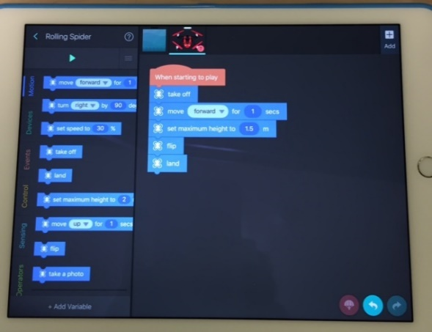
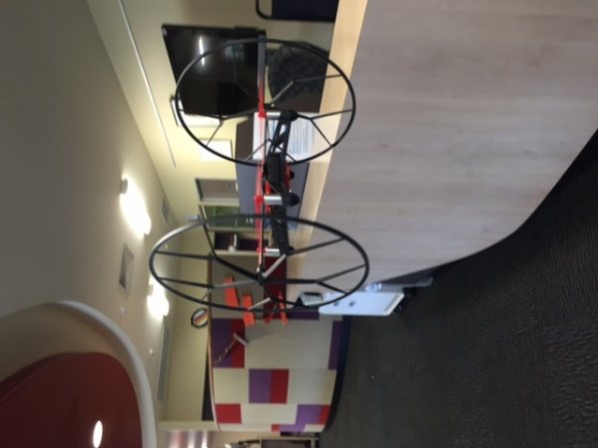
Have Fun!

