NXT Mindstorm

- Open NXT Mindstorm software on computer.

- Design a program to manoeuvre your robot around the course set up on the floor.

- Once you have successfully completed the course, try again this time ask your partner to time it.

- Were you successful? Were the times similar to others doing the course?

- Now you may select another feature to add to your robot, for example a sensor to make your robot start and stop.

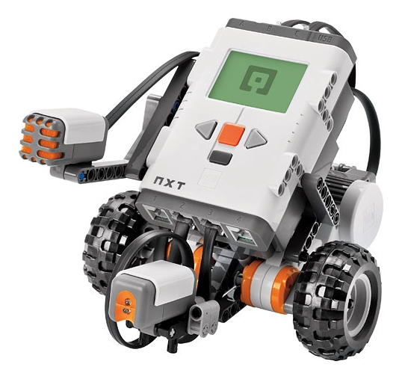
Have Fun!

