Programming BB8

- Open ‘Tickle’ app on the iPads.

- Write a program to get BB8 to complete the following course:

- Start at the hand chair.
- Program BB8 to move to the mirror where he needs to turn 360 degrees, change colours and nod 3 times.
- Program him to move to the dark room where he needs to enter and explore inside.
- Leave the dark room to return to the hand chair.

- Design a course of your own using tickle app to explore other features and incorporate these into your course.

- Were you successful? How many new features did you use?

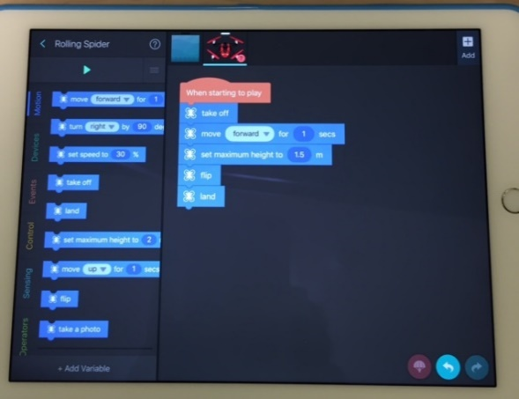
Have Fun!

