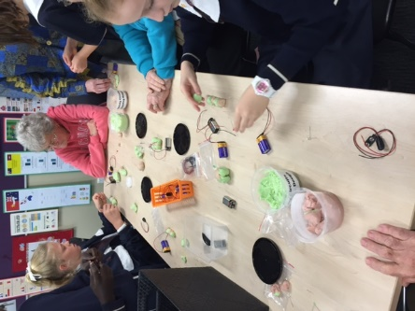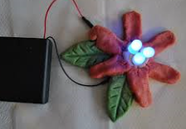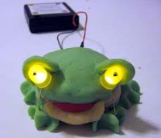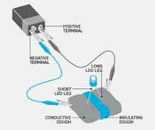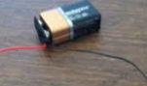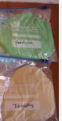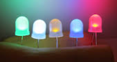**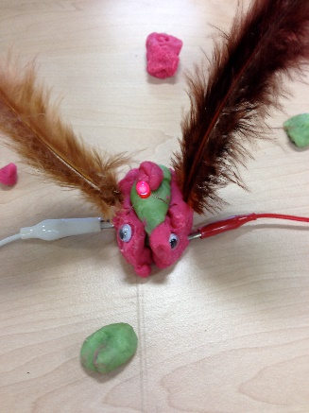 Squishy Circuits**

**3. As can be seen from the diagram make sure the legs on the LED are in conductive dough to make the circuit complete. Once the circuit is complete……have FUN creating and adding to your work!**

**2. Create ‘something’ using the conductive and non-conductive dough. The non-conductive needs to be between the two conductive dough pieces. See diagram**

**Collect together the materials you need:**

**1.Conductive and non-conductive dough, LED lights, wire and battery.**