Sorting Networks

Computers are quick at solving problems. However, there is a limit to how quickly they can work. Sorting out data at the same time can speed up the process. In this activity comparisons are made at the same time.
Using this format the students will sort numbers into order.
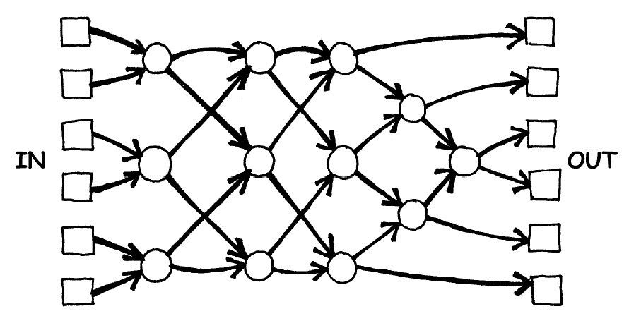
- Each student takes a numbered card.
- Stand in one of the ‘in’ boxes. In random order.
- Each student moves forward.
- In the circle the student with the largest number moves to the right.
- Continue this until each student arrives in the ‘out’ box.
- Now all students should be in number order, if not re-do!

Example:
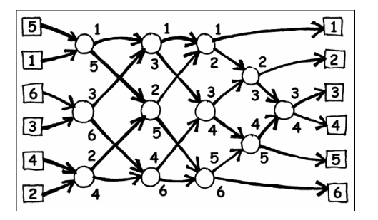
Now try larger numbers to make it more challenging!

