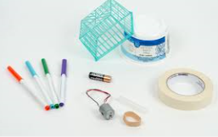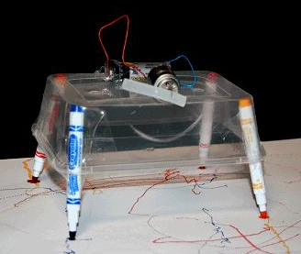 **Scribbling Machines**

**Collect together the materials you need:**

**1.Motor, battery, pencils/textas, masking tape, sticky tape or blu-tak and wire.**

**2. Create circuit using battery, wires and motor.**

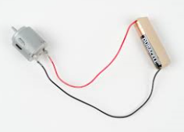

**3. Tape circuit onto the top on a container and tape pens in place.**

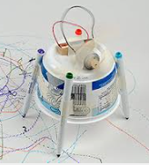

**4. To make the machine wobble and move in different directions the motor needs to be weighted off centre by attaching a stick or blu-tac.**

