Robot Makes a Sandwich

In this activity students simply give directions to a “robot” (another student) to find out which instructions the robot is able to follow, and how their instructions are taken literally.

Automation and Computation
Programming a robot to carry out directions and being able to debug any errors.

Video of the activity.

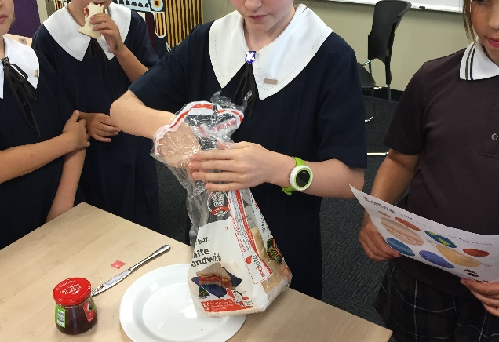

- Place a bag of sliced bread, jar of jam with lid on, plate and a knife onto a table.
- Students write instructions step by step to take a slice of bread and spread it with jam on the plate.
- Students then take it in turn to read instructions out and robot follows.
- Fix any mistakes (debugging) in instructions (program).
- Once task is complete robot may enjoy sandwich!

