Position, Direction and Location Game

This game improves skills in directional language and programming through sequences of forwards, backwards, left and right turns.

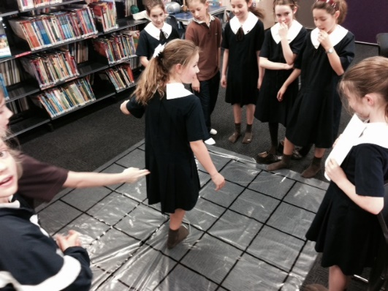

The aim of the game is to get from one side of the mat to the other following directions of forwards, backwards, left and right. If you come off the mat at the side then your turn is finished. The number of cards used can be changed to increase difficulty.

- Place plastic mat on floor.
- Decide the number of cards to be used to give directions.
- Shuffle the cards.
- One student reads directions from turning over cards one at a time.
- The student on the game follows directions, just like a robot.
- Success is getting to the other side of the mat without coming off at the sides.
- Game can be played in teams to see which team gets most members across.

