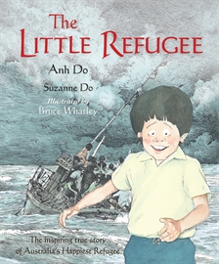
Making Australia Home: Phases of Migration to Australia over time
Who has migrated to Australia over time and what impact have migrants had on Australian society and identity?
Year Six History Assessment, Term 4 2015
Task A: Your task is to think of a wide range of questions to research the overarching question: Who has migrated to Australia over time and what impact have migrants had on Australian society and identity?
- With your partner, select either a known migrant or refugee or unknown migrant or refugee to investigate.
- Using the focus questions provided, research the migrant or refugee, and record your findings in a Word document.
- Locate both primary and secondary sources as part of your research to support your findings (images, photographs, documents, cartoons). Your partnership must refer to, at a minimum, one primary and two secondary sources and be accompanied by a Reference List.
- Present a short animation of your migrant’s or refugee’s story.
Presentation
In order to prepare your animation, think about including some of the following in your final piece:
- Pictures……drawn, painted, background
- Photos……family, environment
- Maps…..journey, route
- Dates……headings, time lapse
- Quotes…..written, spoken
Historical Language
When writing responses to your questions, you must include historical language. Historical language refers to terms that relate to the topic you are investigating. For example, terms related to migrants include identity, society, contribution, refugee, asylum seekers, suppressed and multiculturalism.

Assignment Timeline: Please tick once you have completed each requirement. Following a sequence of steps will help you stay on track and meet all of the time requirements.
Week One:
- Select a migrant or refugee to study.
- Allocate research tasks within your partnership, referring to the Partnership criteria sheet.
- Begin research based on the focus questions and take notes in your Word document.
- Make sure you fill in your reference sheet. This will also be assessed.
Week Two:
- Continue with your research.
- Complete answering the focus questions provided, using quotes and images to build up your story. Your animation must include the following:
    - Title
    - Introduction
    - Where the person has come from
    - How the person settled in Australia
    - What the person contributed and/or is doing in Australia
    - Conclusion
- After you have completed your focus questions, meet with the teacher for a conference.
- Plan out your animation storyboard.
- Use the primary and secondary sources you have found as part of your research to provide a visually appealing and informative migrant story.
- Remember to keep your reference list updated.
Week Three:
- Create your Animation
- Animation is limited to one and a half minutes.
- The work creating the animation should be divided between you and your partner.
Week Four:
- Completed Task ready to email.
Task B
- You and your partner will design an activity to assist a new migrant or refugee to settle into Brisbane, Australia.

Junior School Library

Reference List
Tips for compiling your good copy:
- Entries are to be listed in alphabetical order (using author surname), or title if there is no author.
- If your reference list is handwritten, titles should be underlined.
- Your reference list should be written and submitted separately and attached to your Storyboard

Books
Author |  | Year | ‘Title’ | Publisher | Place
Surname | Initial

Reference Books
Author |  | Year | ‘Title of reference book’ | Vol No | Page No/s | Publisher | Place
Surname | Initial

Internet
Author/Organisation |  | ‘Title of page accessed’ | Date accessed | Http
Surname | Initial

Interview/Phone Communication/Personal Communication
Author |  | Year | personal communication | Day | Month
Surname | Initials
 |  |  | personal communication
 |  |  | personal communication

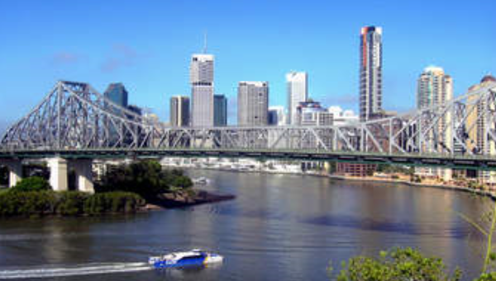
- Discuss the types of activities and issues a girl of your age would like to know when arriving into a new country ……shops, food, movies, sports, money, hobbies, schools, traditions, holidays, language/slang etc.
- Decide on an aspect you think you and your partner could develop. You may use technology and physical objects.
Week Five
- Research how your idea could assist a new migrant or refugee. Consider some of the issues your migrant or refugee had from Task A.
- Briefly describe your idea and how it works.
- Start to make or create your activity which can be displayed for the International Department to view.
Week Six
- Present your idea/activity to the International School Representative.
- Share your animation with the class.
Week Seven
- Evaluation

http://howsports.blogspot.in/2011/12/sports-face-paint.html

